***List Of Experiments Along with***

***Codes and Outputs***

1. Write a program to calculate the factorial of an integer.

**Source Code:**

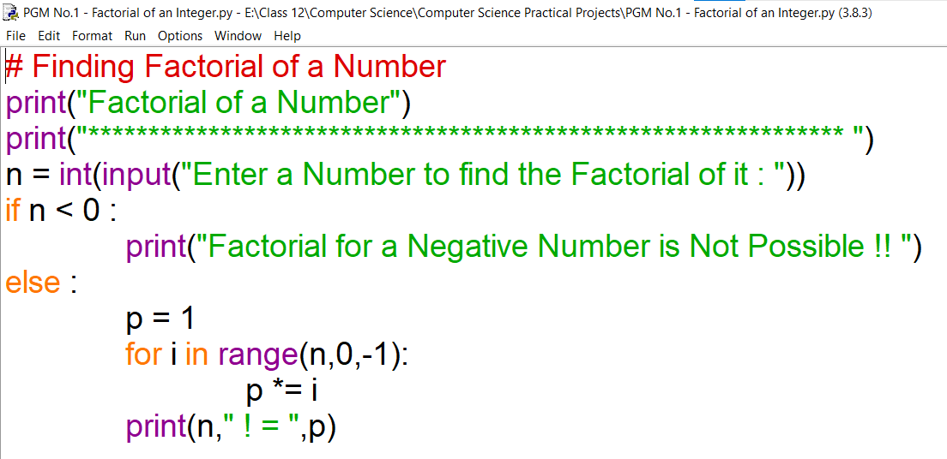

**Input/Output:**

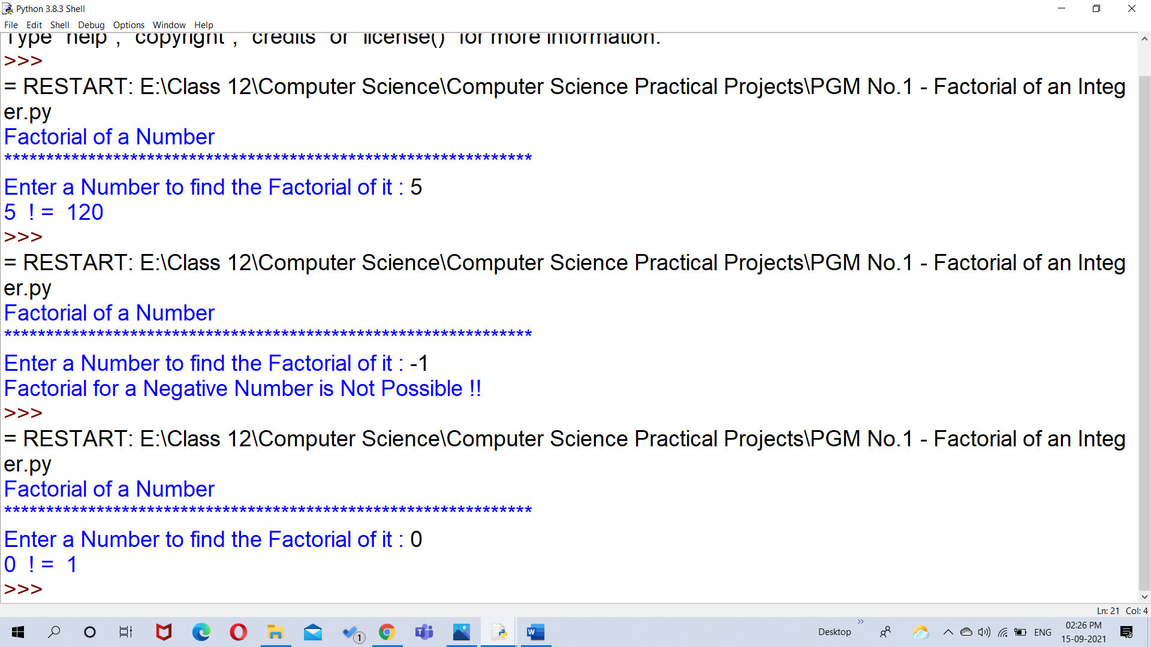

1. Write a program to print Fibonacci series.

**Source Code:**

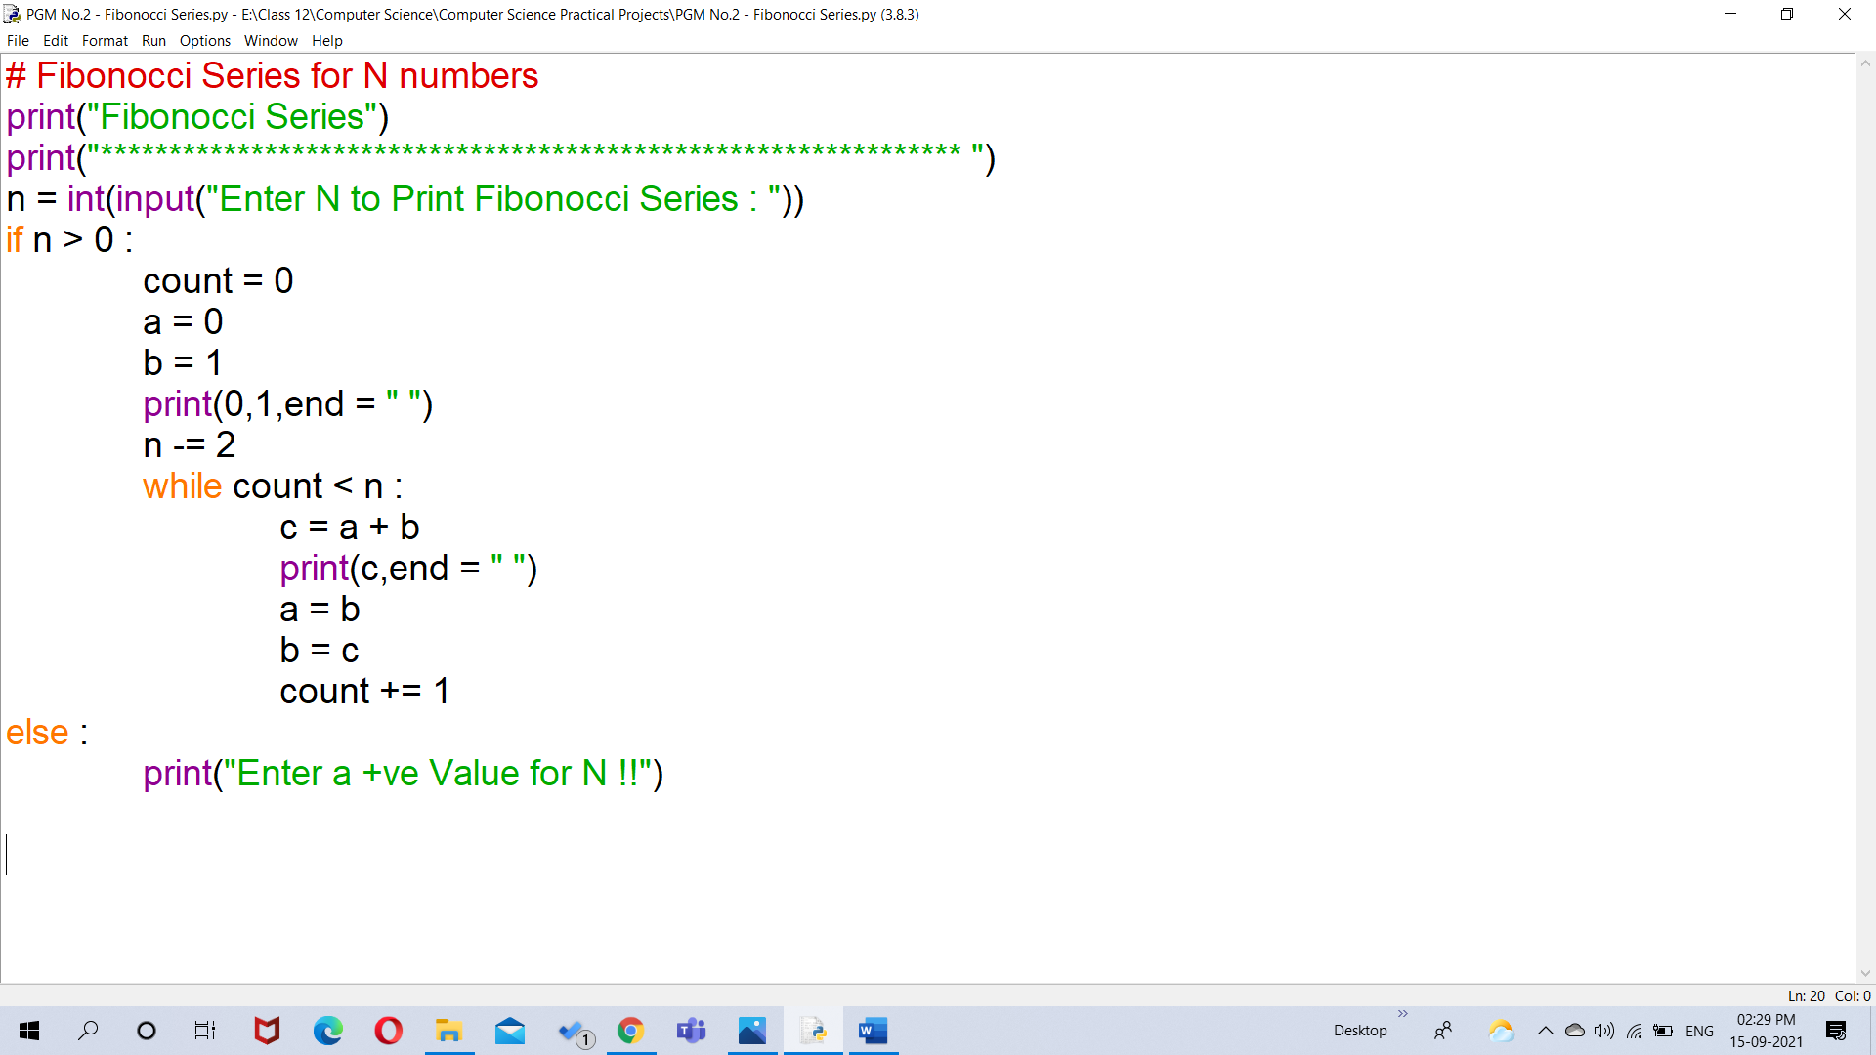

**Input/Output:**

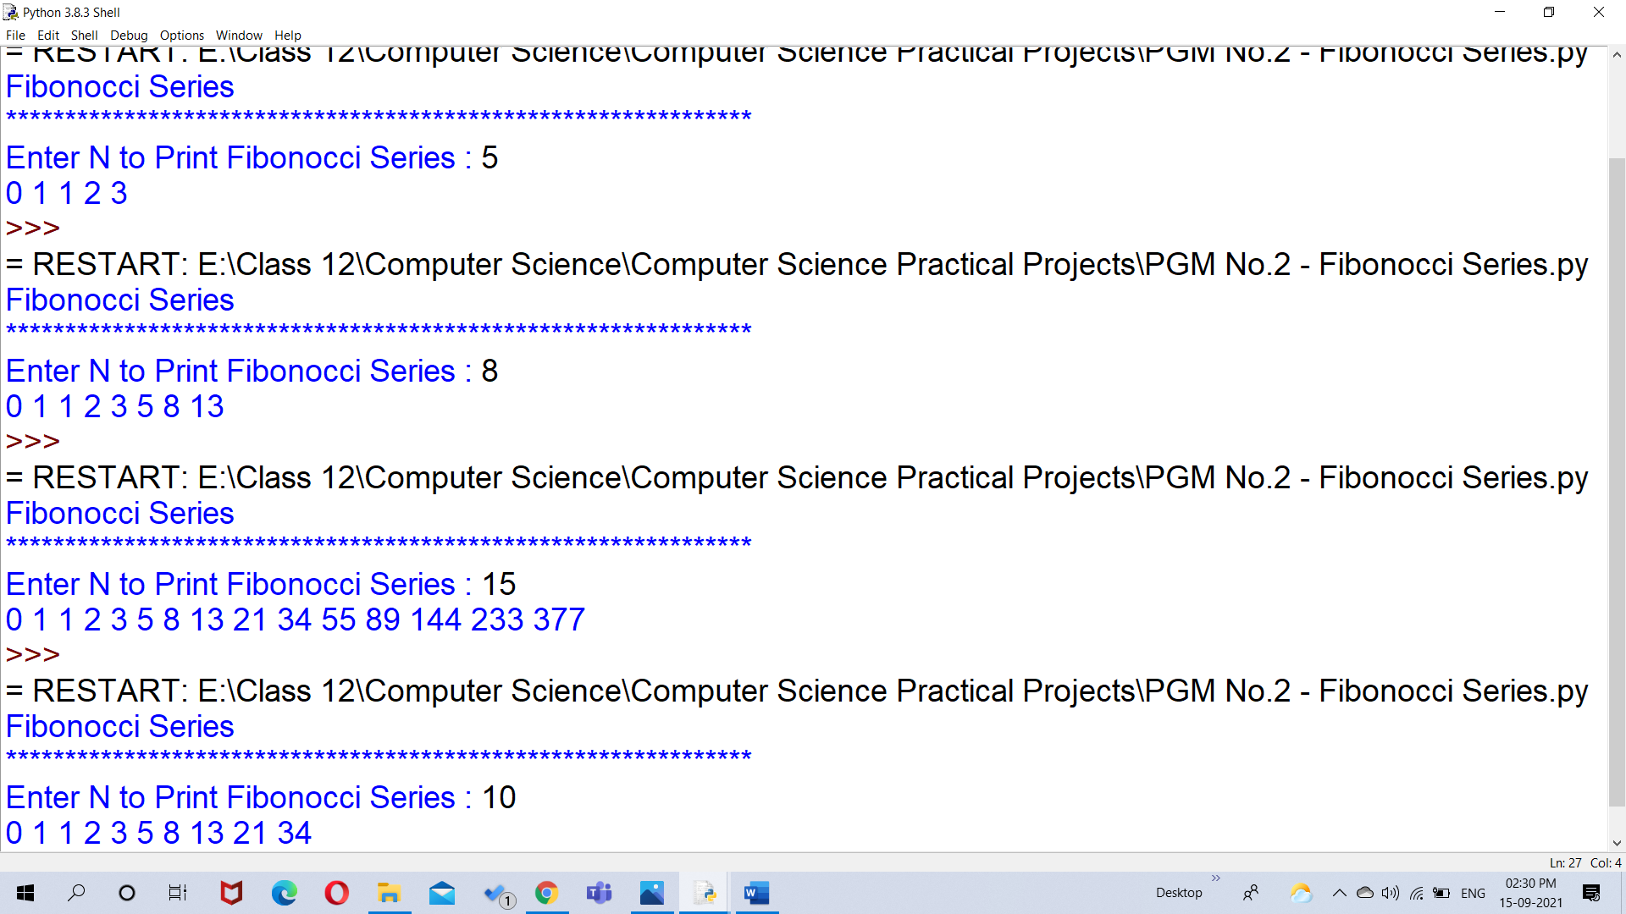

1. Write a python program to sum the sequence given below.

**Source Code:**

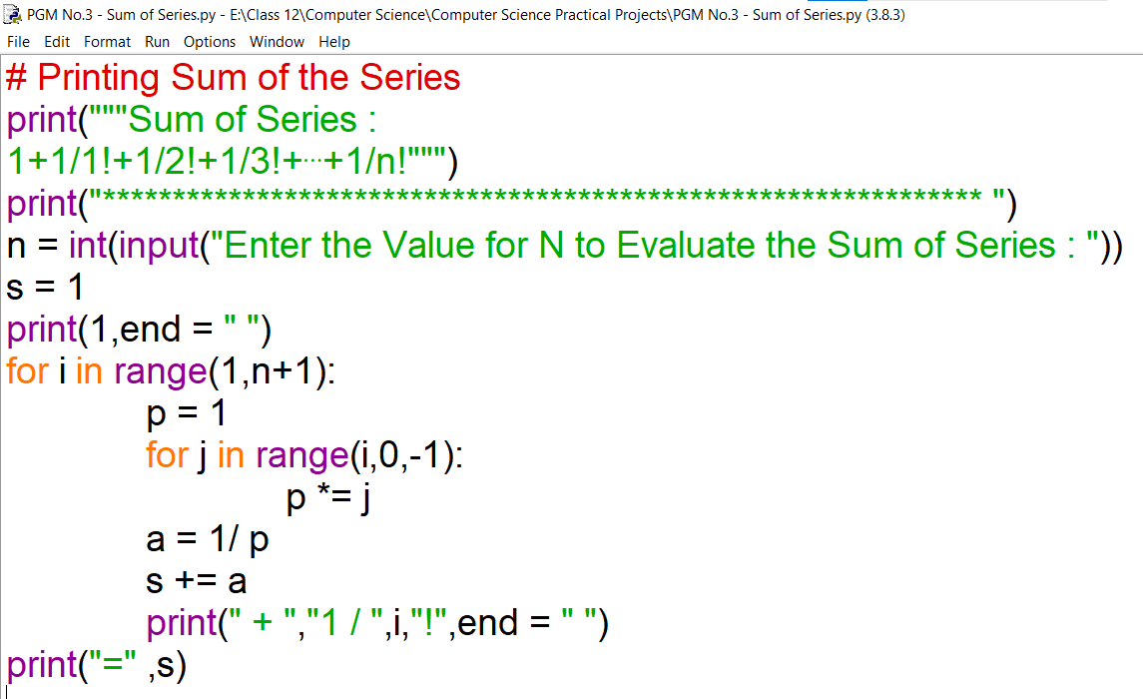

**Input/Output:**

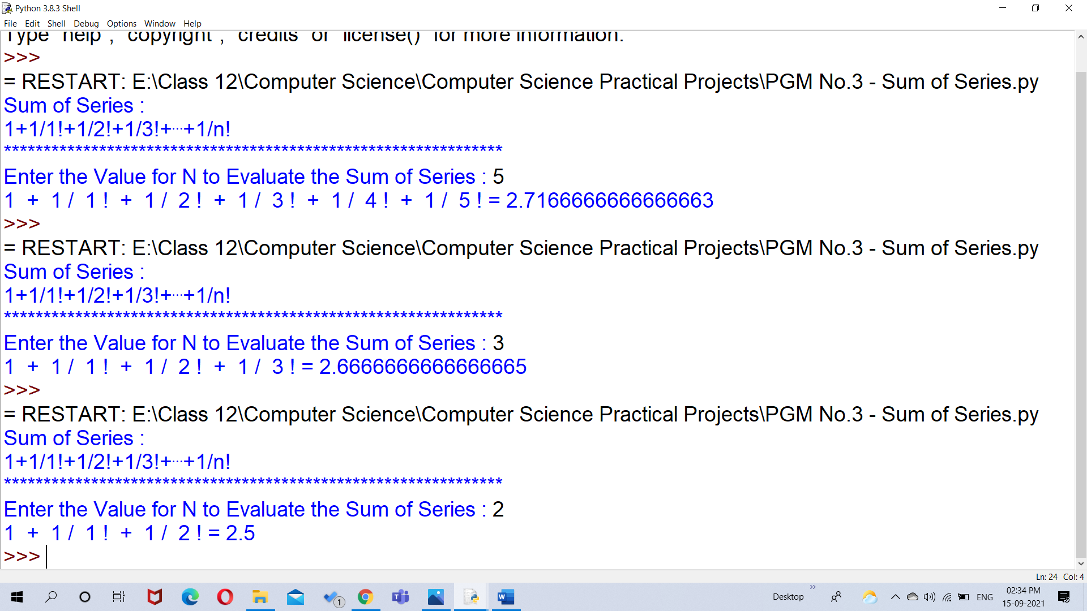

1. Write a program for Linear search.

**Source Code:**

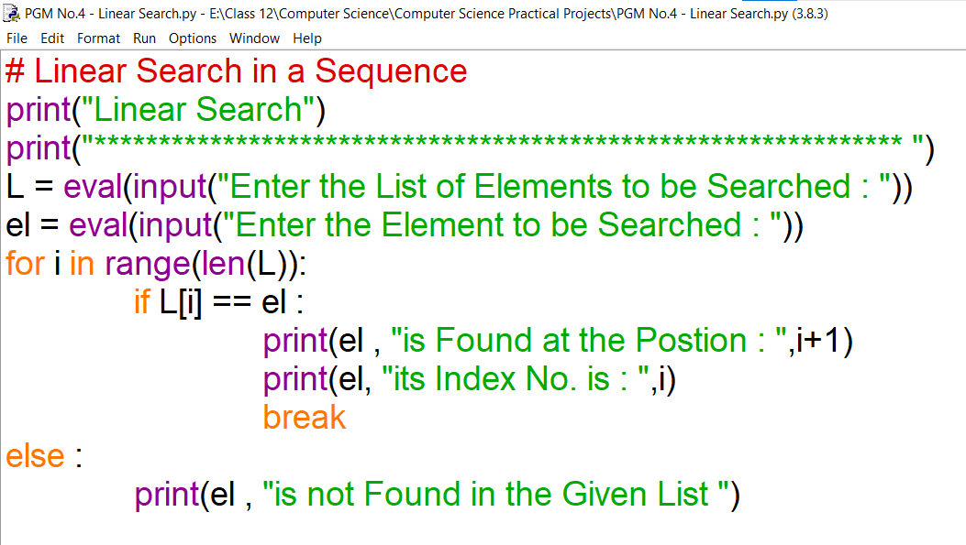

**Input/Output:**

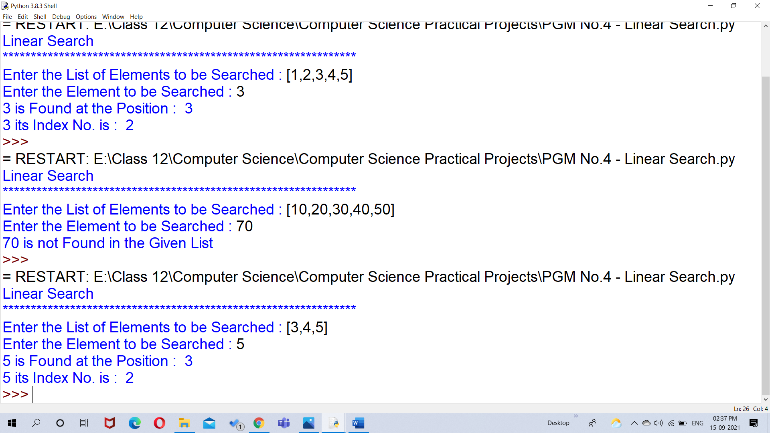

1. Write a program to check a number whether it is palindrome or not.

**Source Code:**

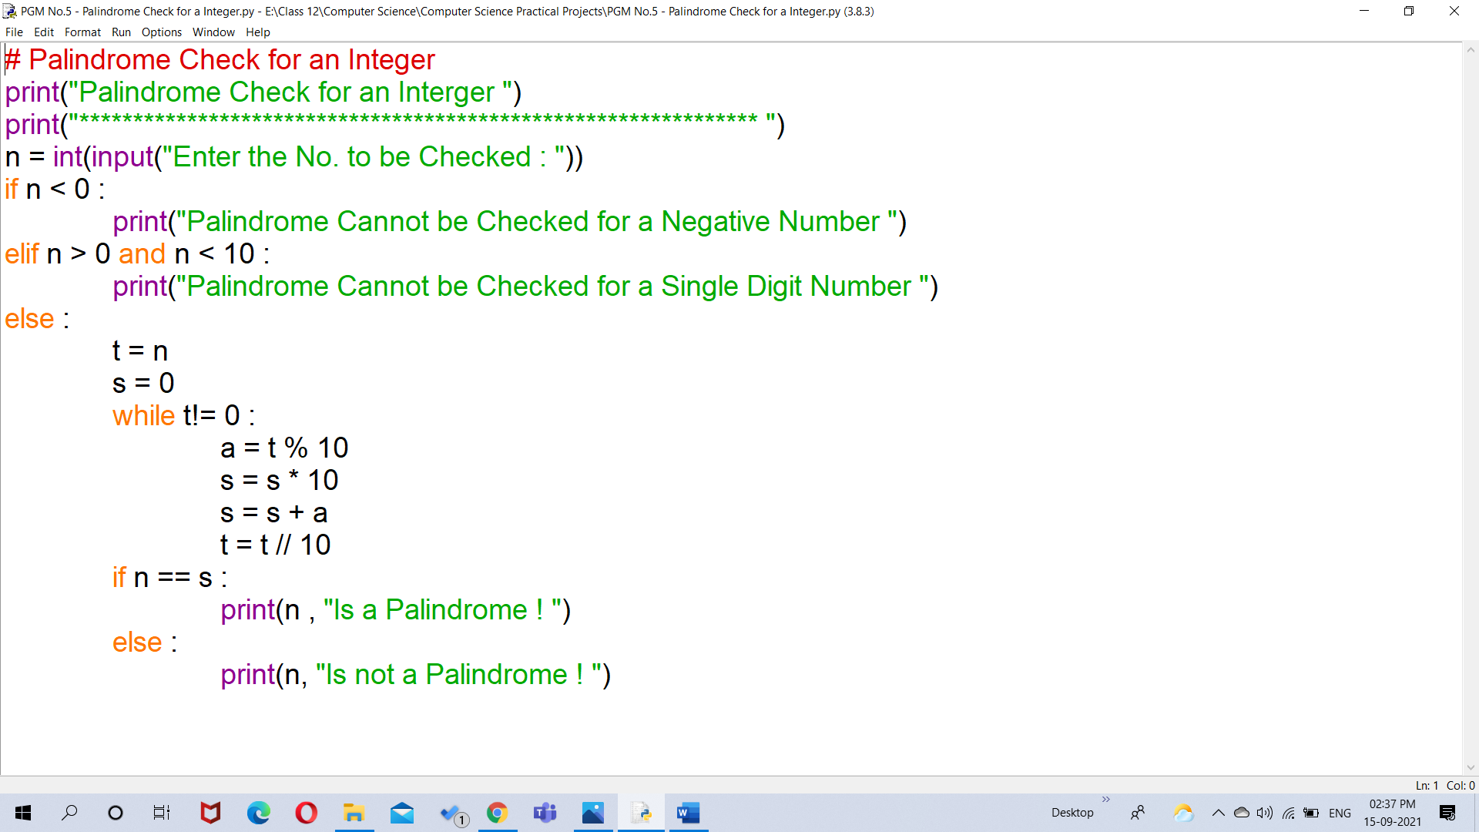

**Input/Output:**

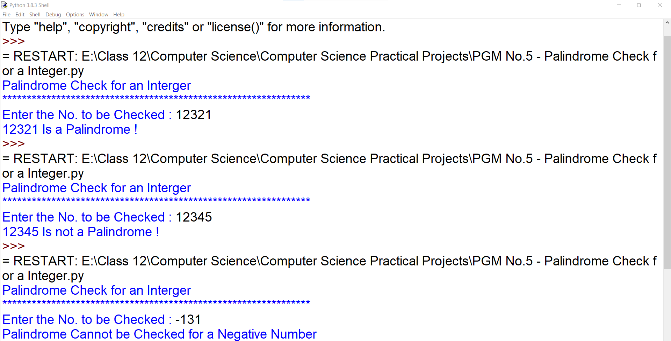

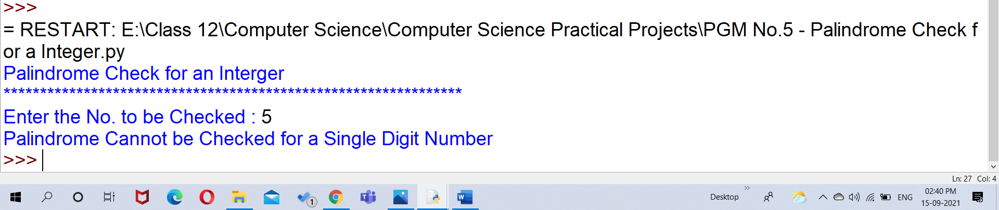

1. Write a program to read a text file line by line and display each word separated by '#'.

**Source Code:**

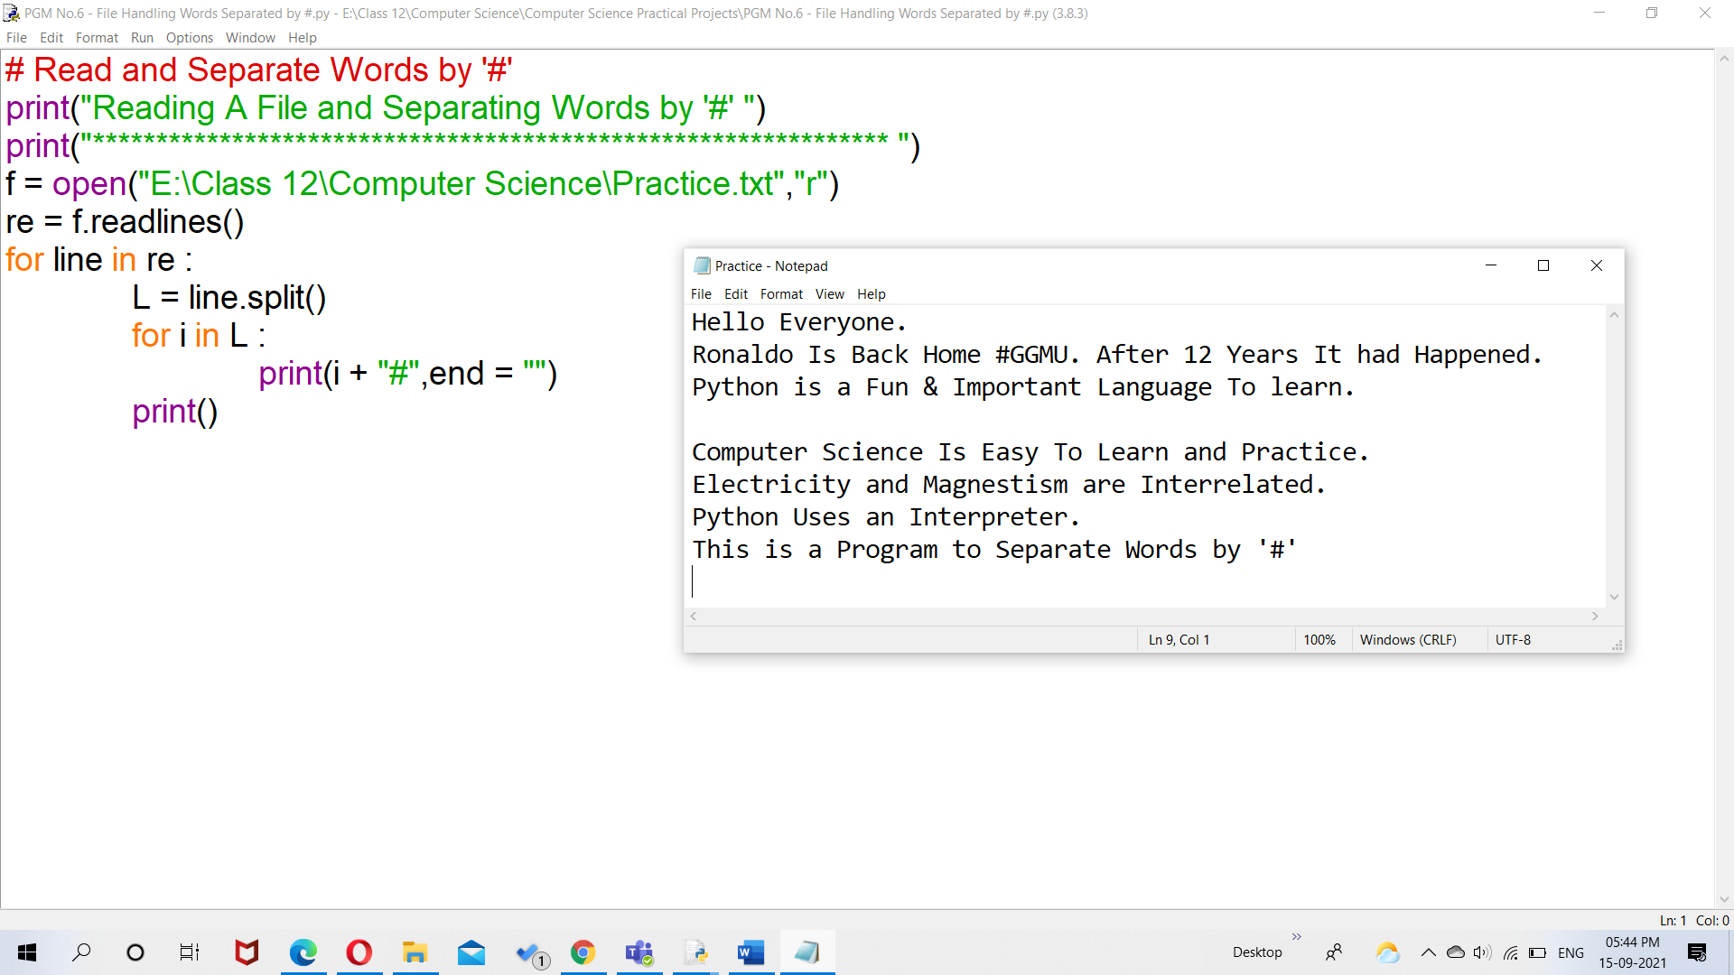

**Input/Output :**

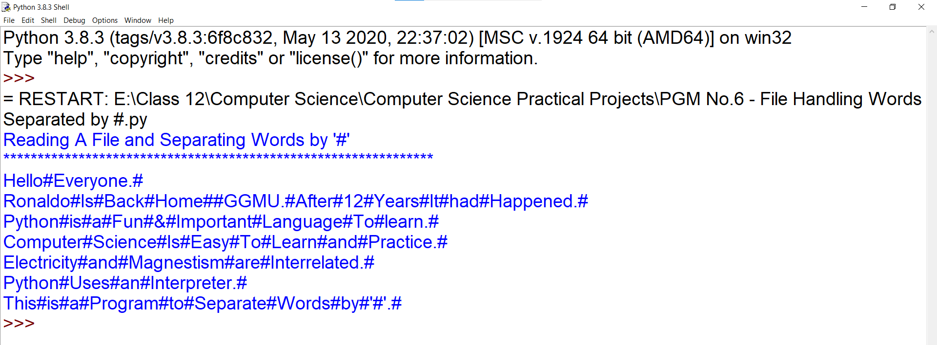

1. Write a program to count the number of vowels /consonants/uppercase \lowercase characters present in a text file.

**Source Code:**

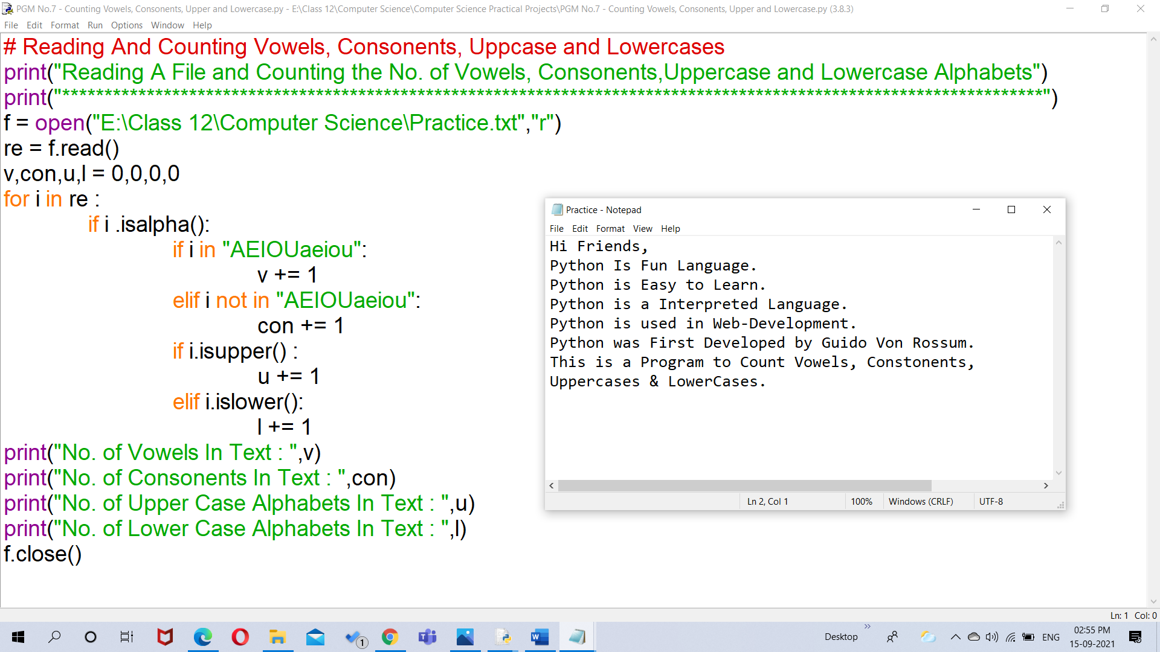

**Input/Output:**

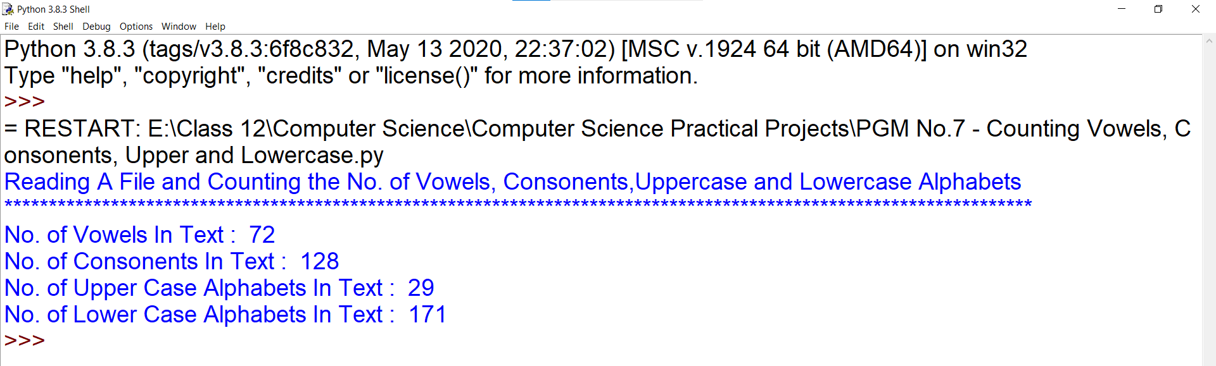

1. Write a program to count the number of times the occurrence of 'is' and ‘was’ word in a text file.

**Source Code:**

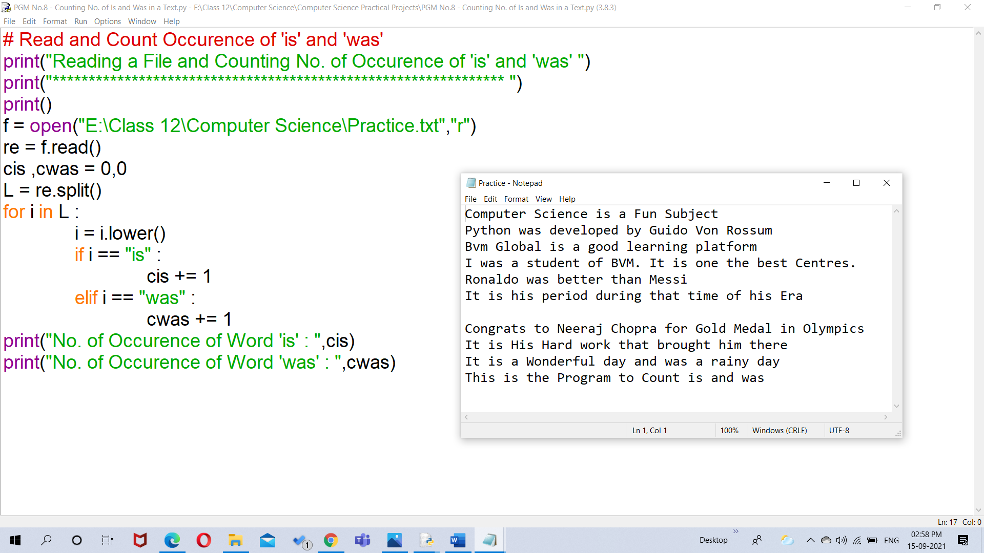

**Input/Output:**

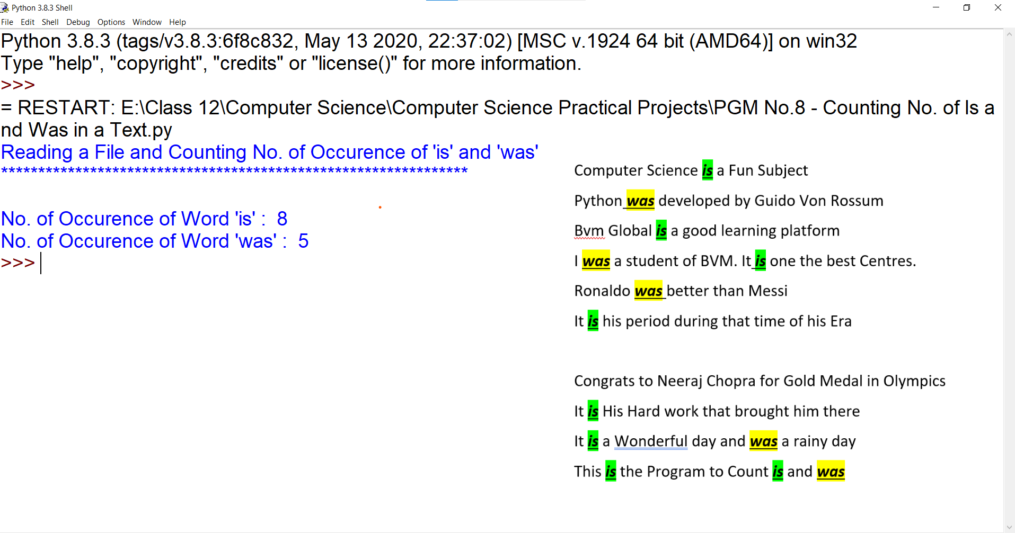

1. Write a program to write those lines which starts with character 'p' or ‘P’ from one text file to another text file.

**Source Code:**

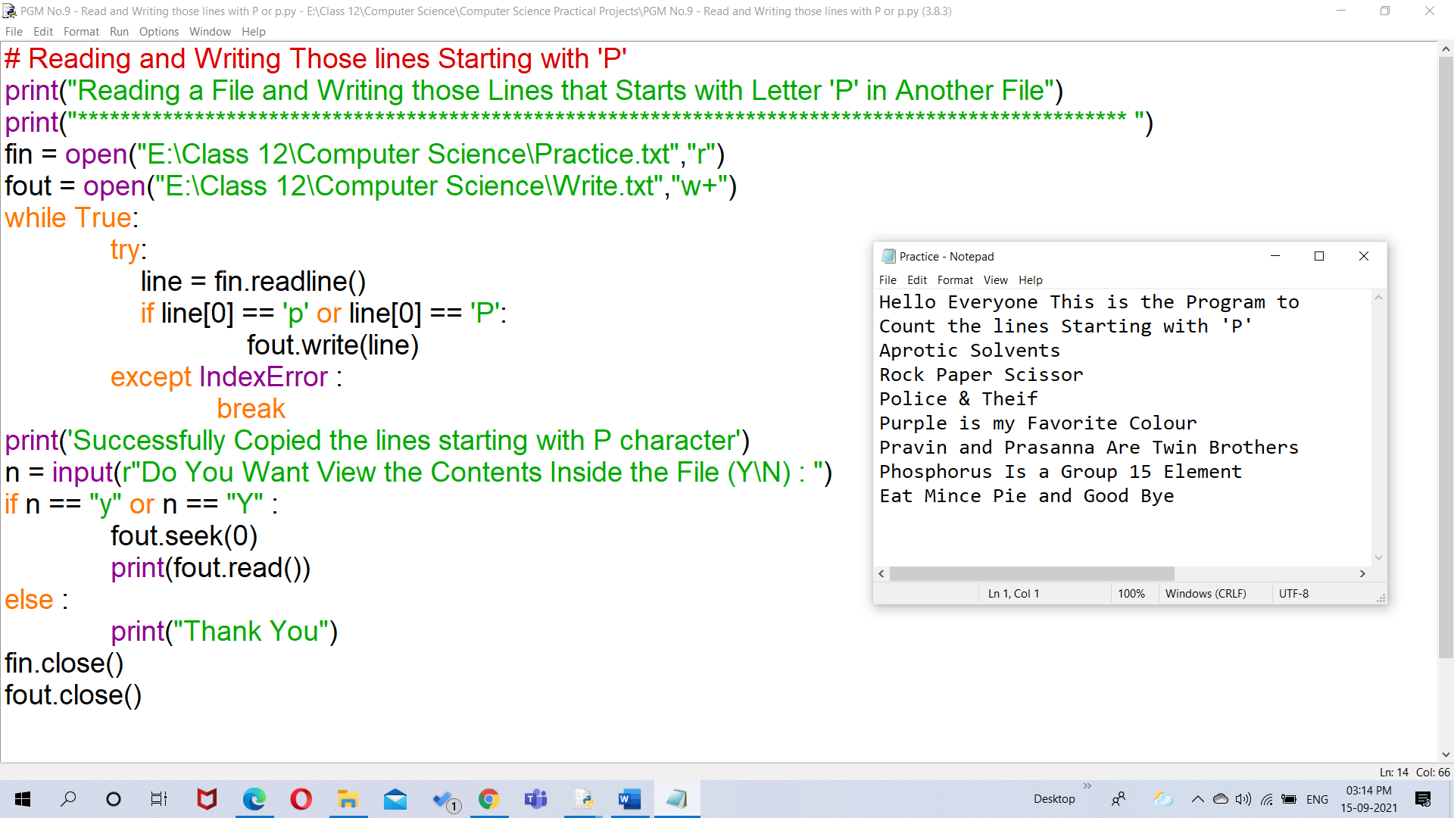

**Input/Output:**

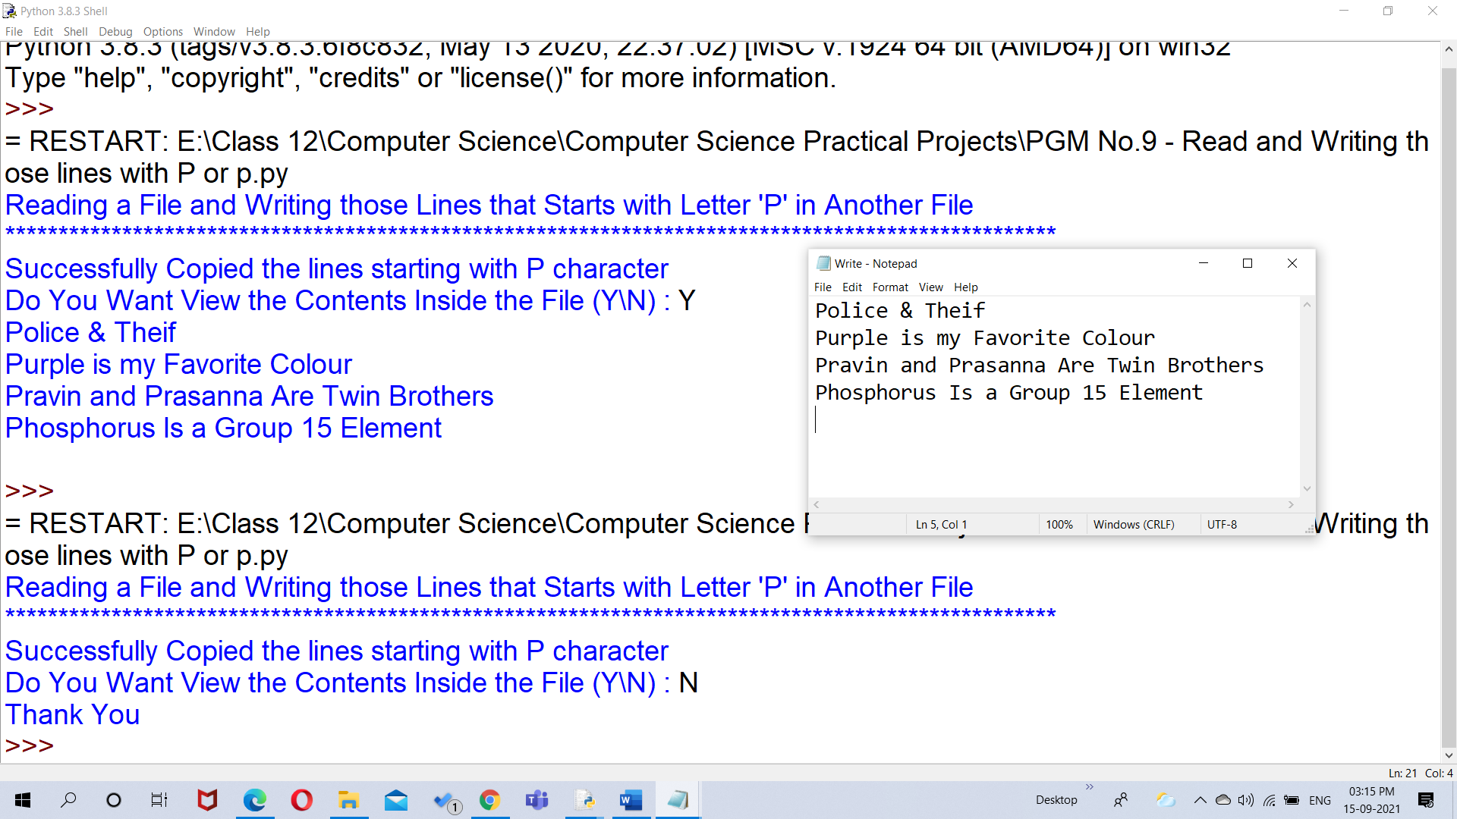

1. Create a binary file with name and roll number of student and display the data by reading the file.

**Source Code:**

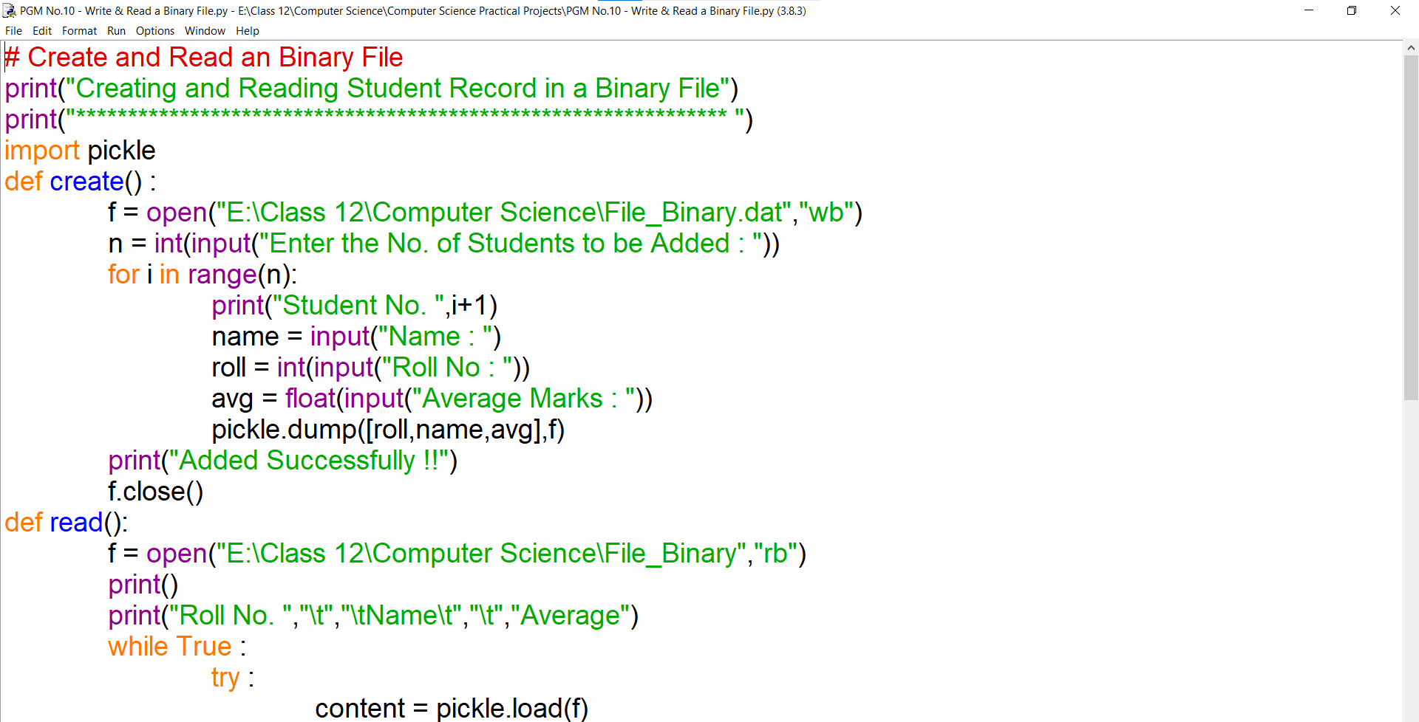

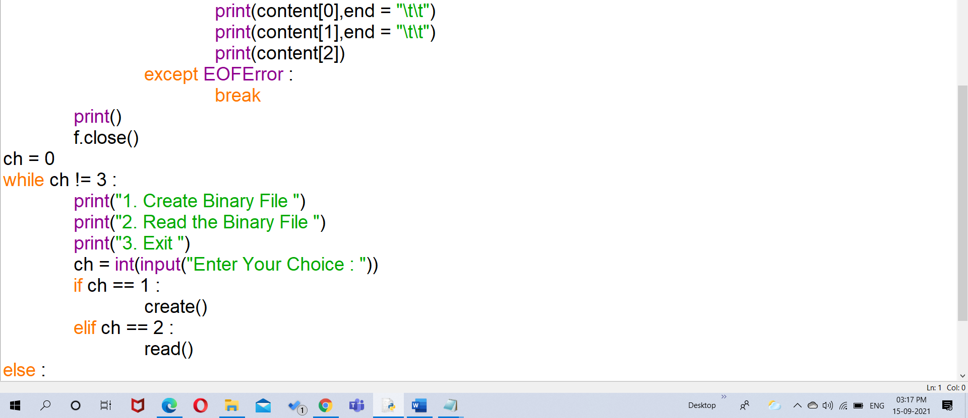

**Input/Output:**

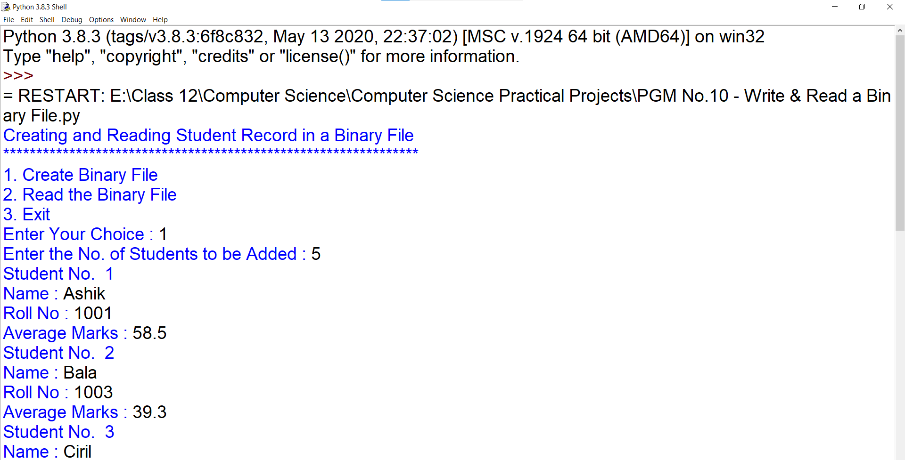

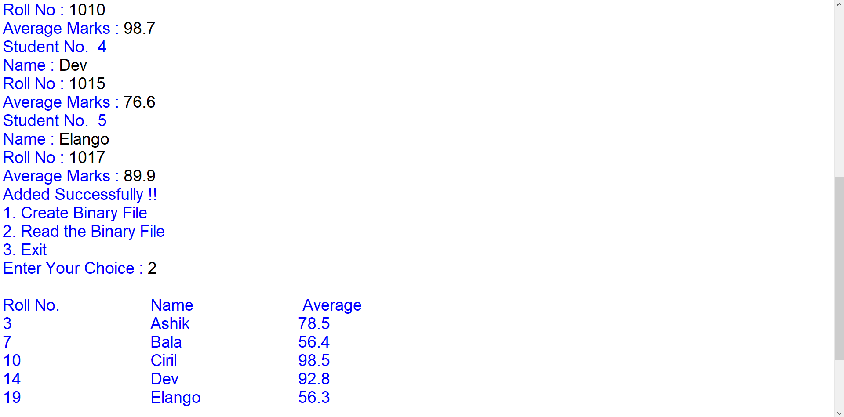

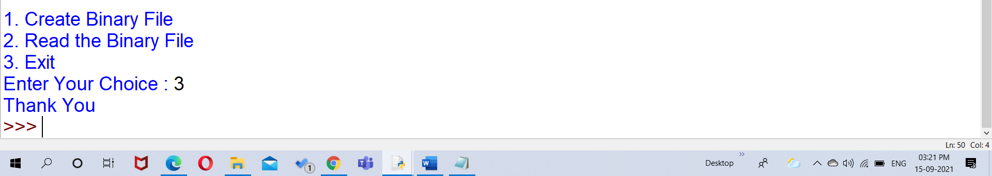

1. Write a program to search a record using its roll number and display the name of student. If record not found then display appropriate message.

**Source Code:**

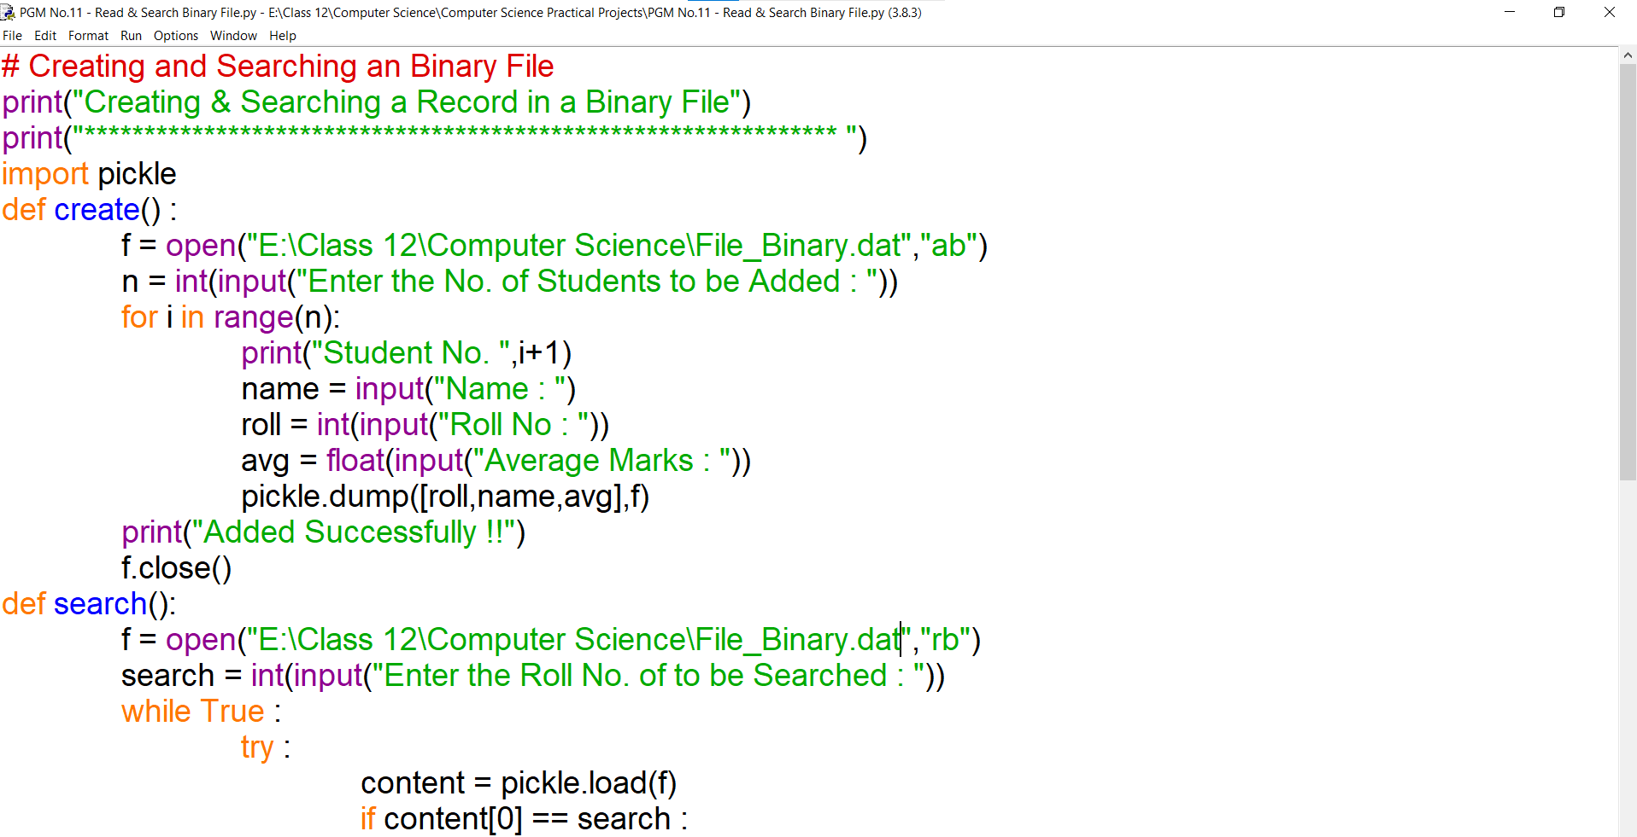

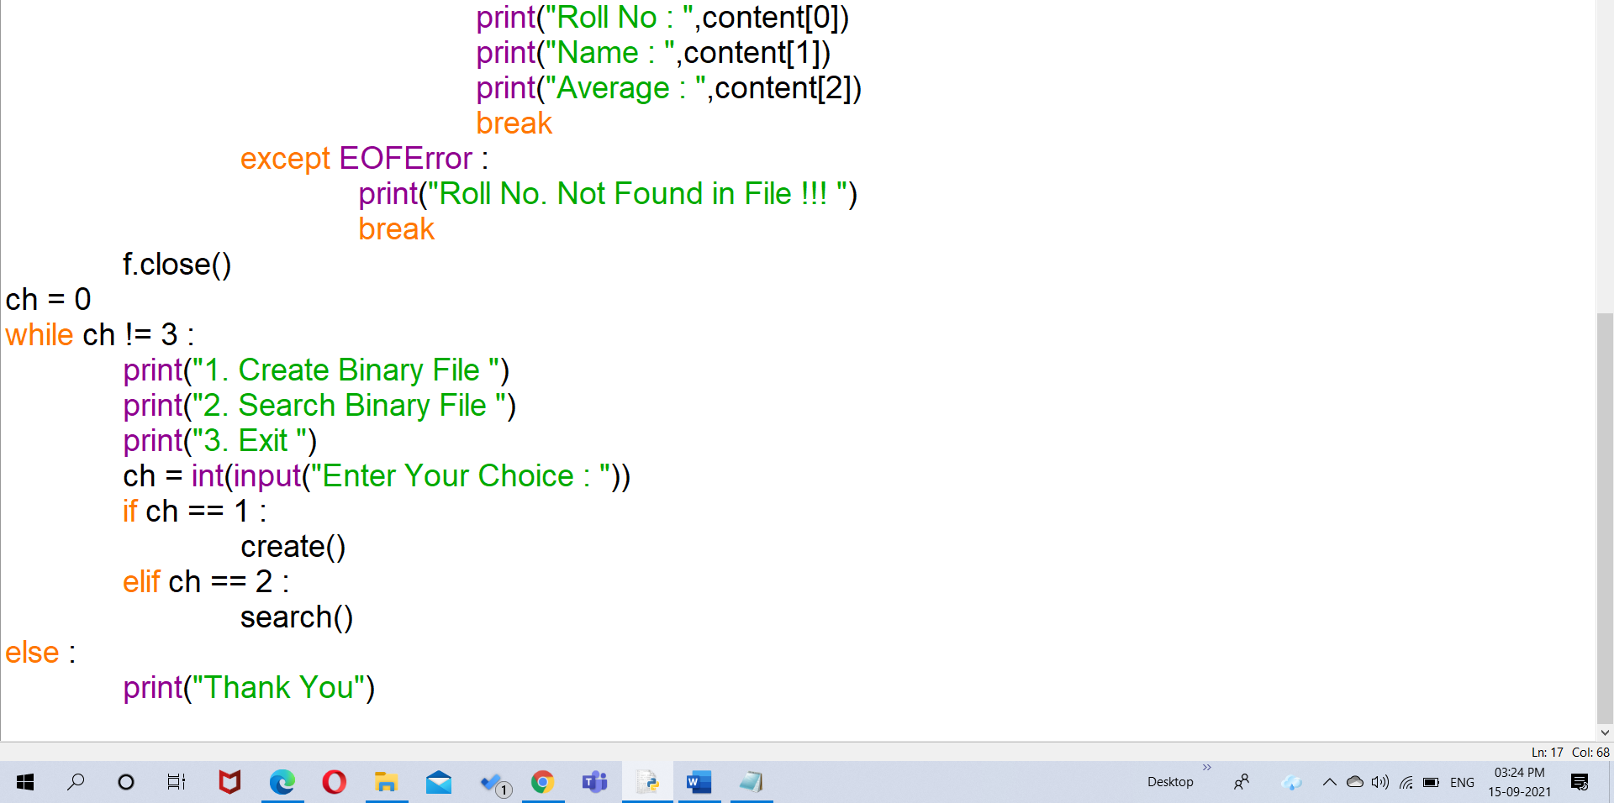

**Input/Output:**

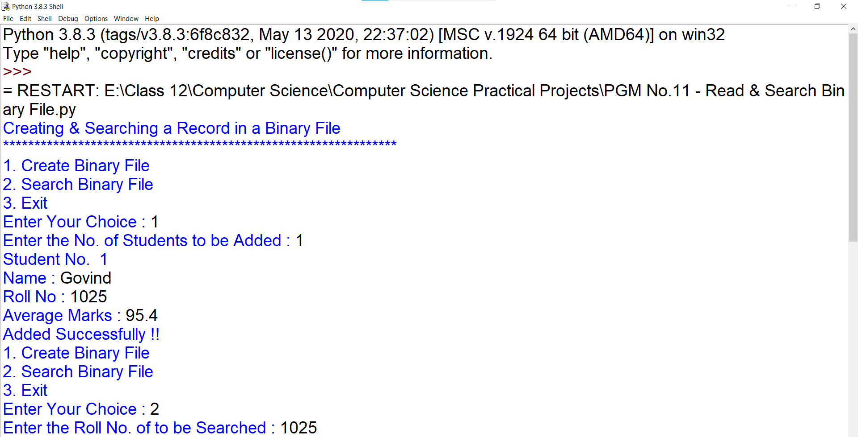

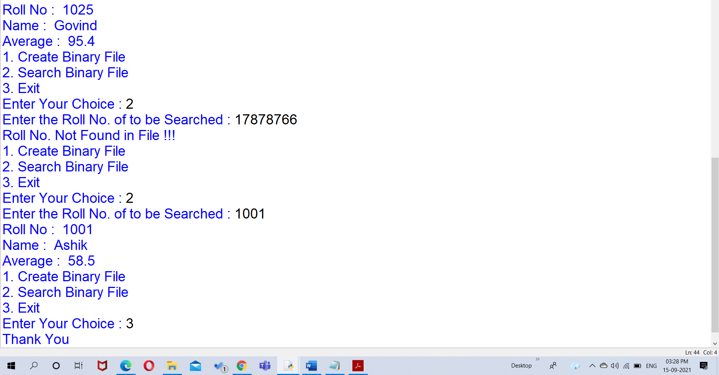

1. Write a program to update the name of student by using its roll number in a binary file.

**Source Code:**

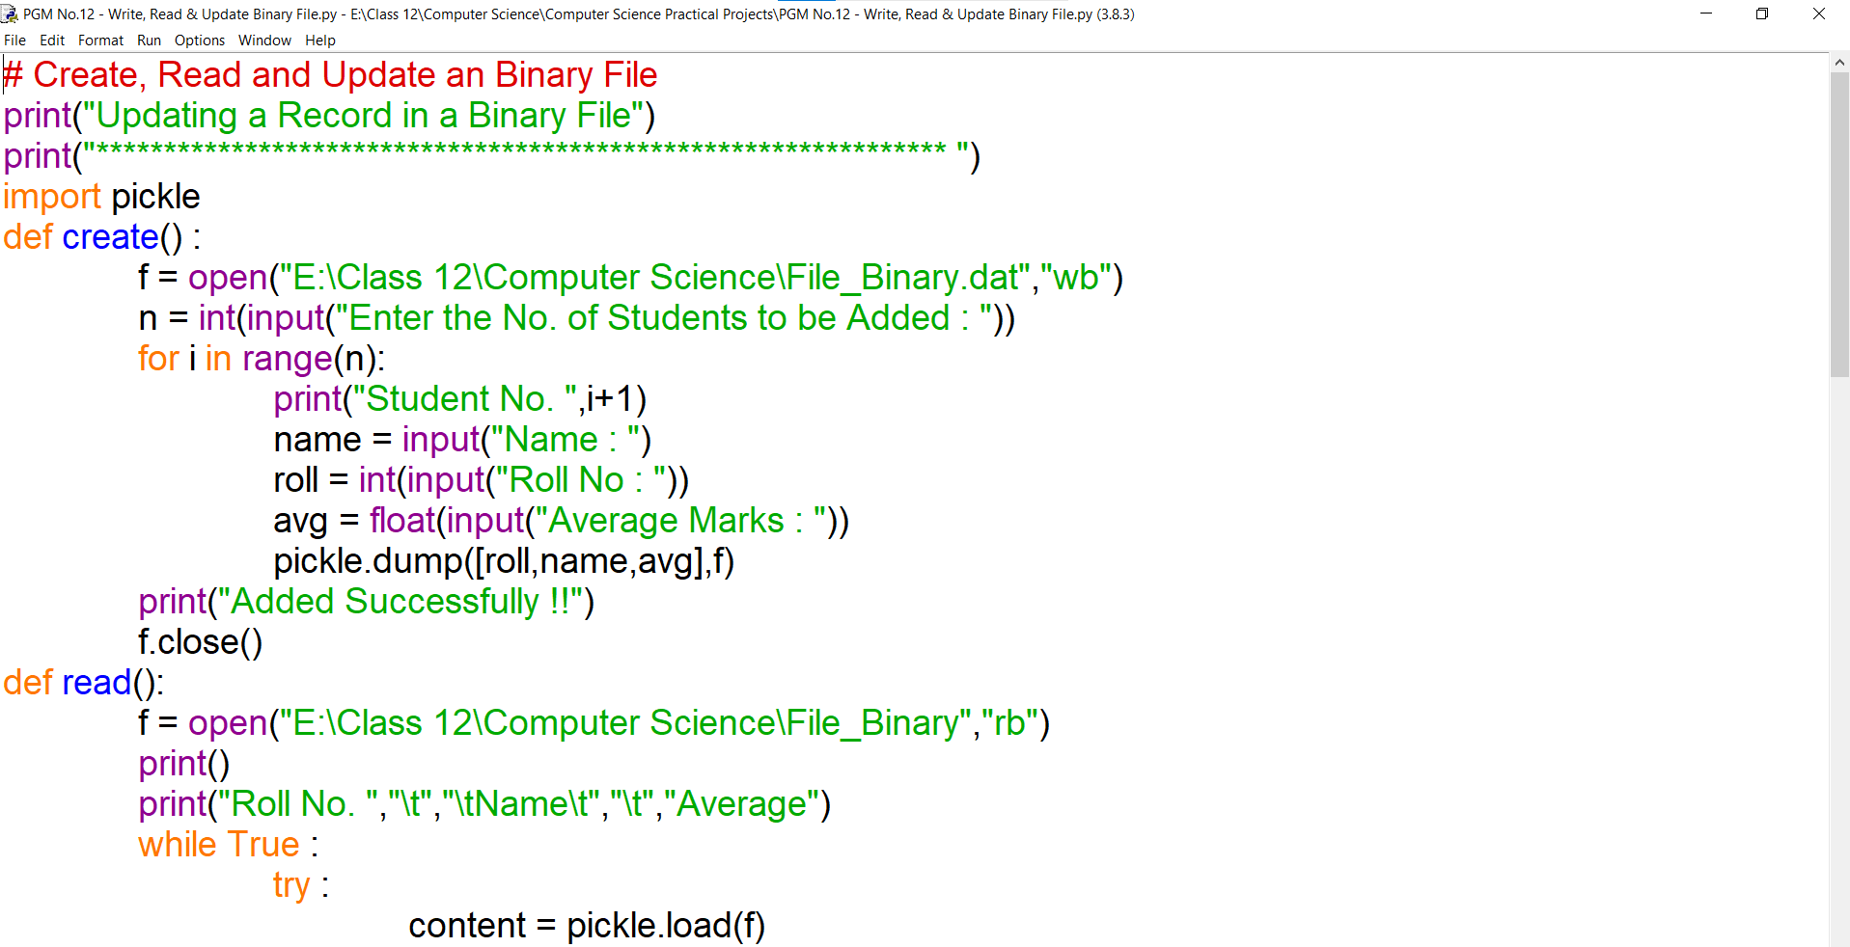

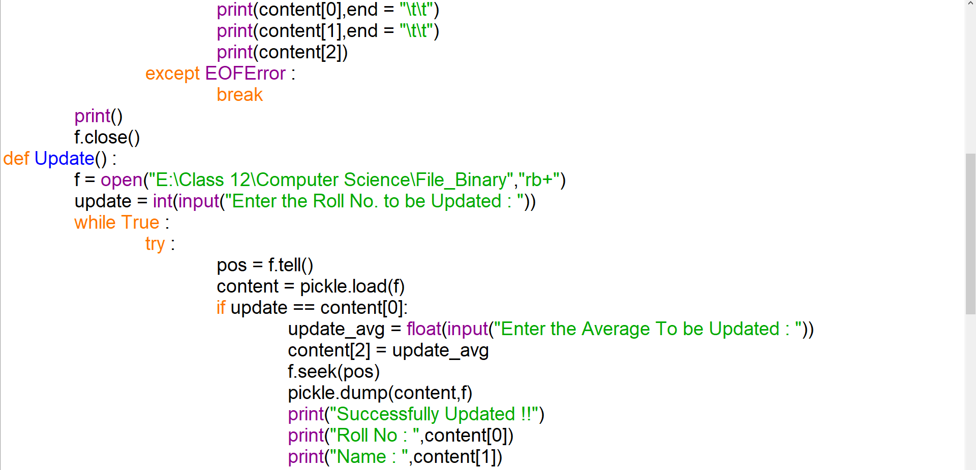

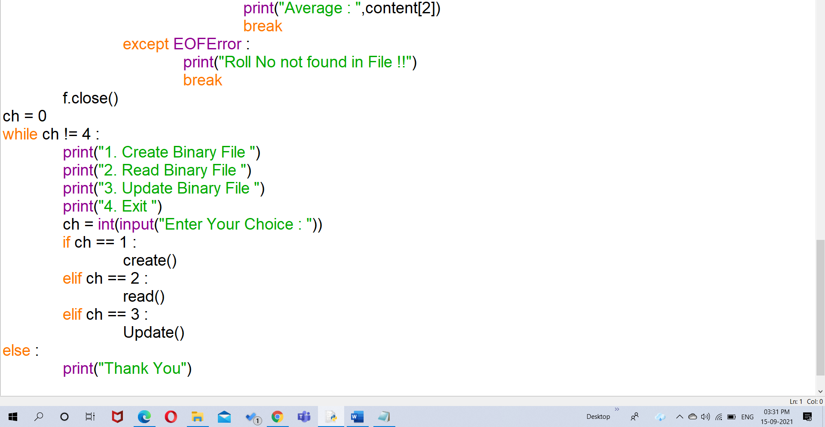

**Input/Output:**

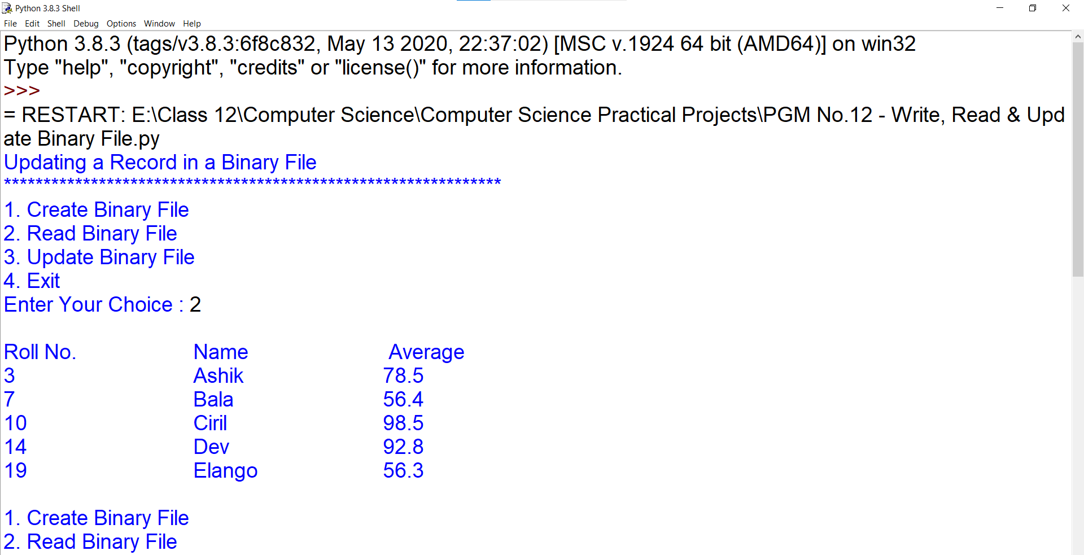

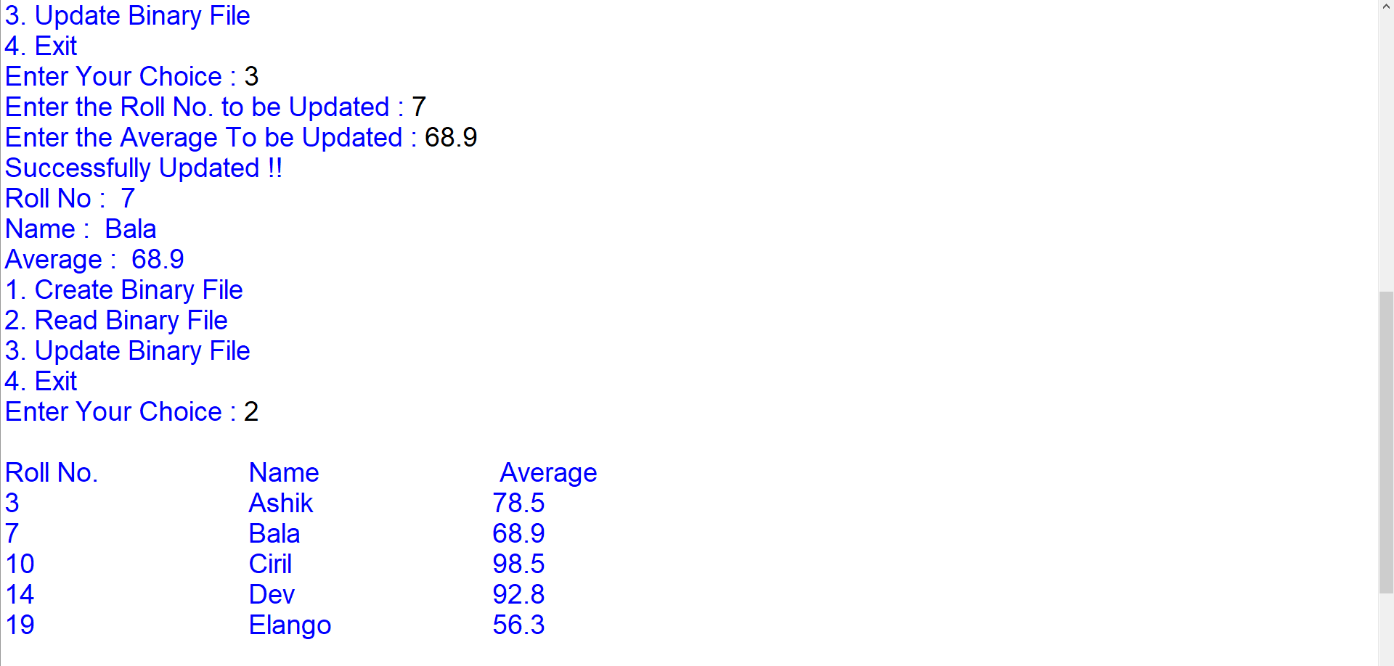

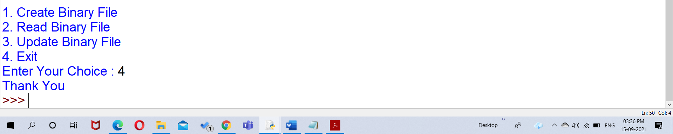

1. To write a Python program Create a CSV file to store Empno, Name, Salary and search any Empno and display Name, Salary and if not found display appropriate message.

**Source Code:**

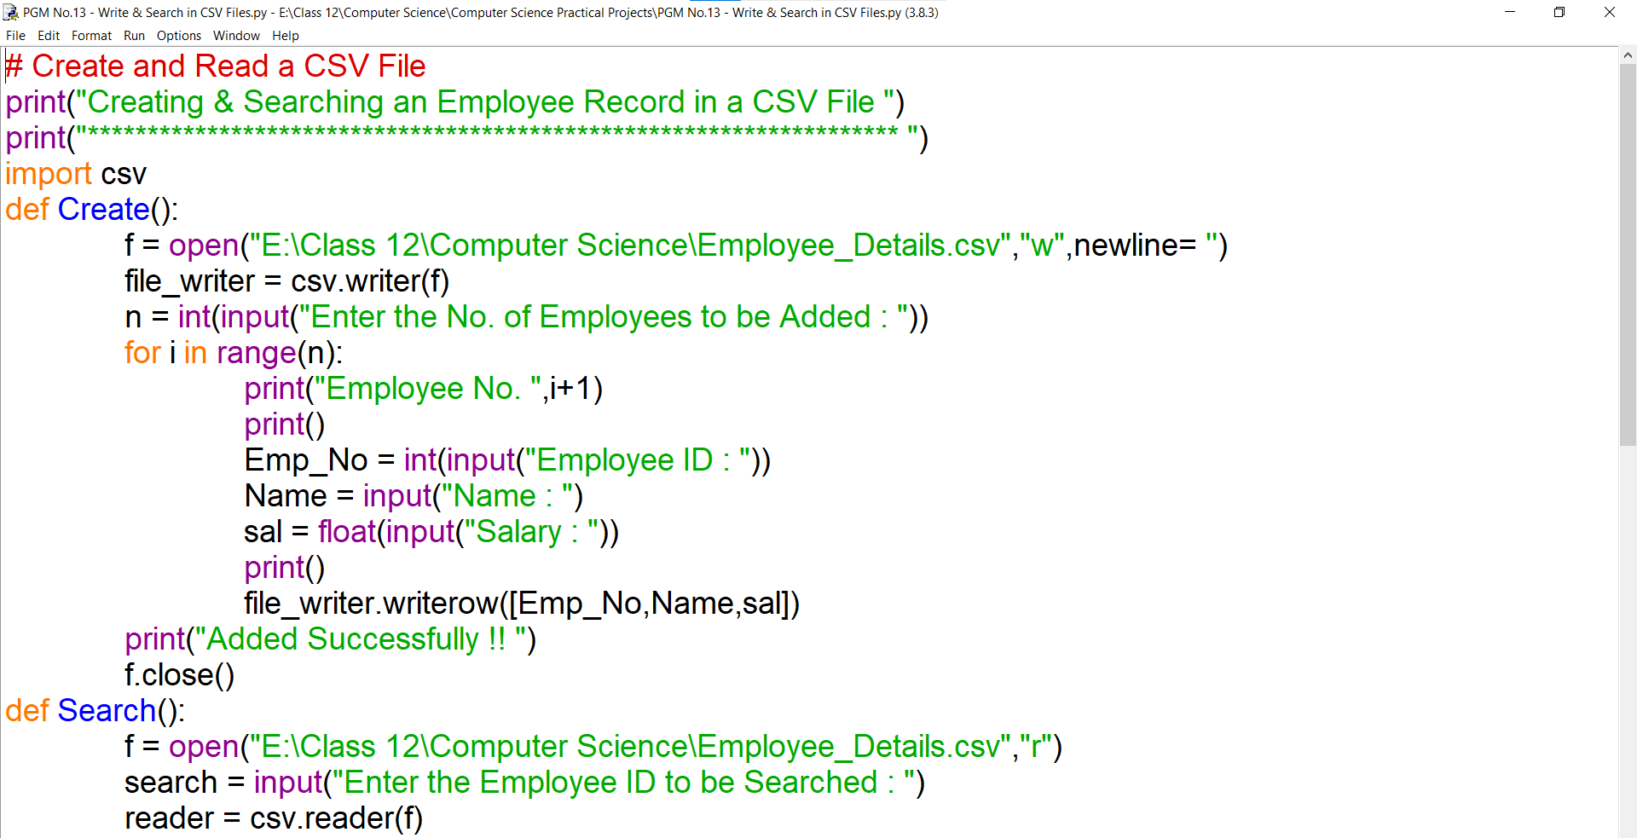

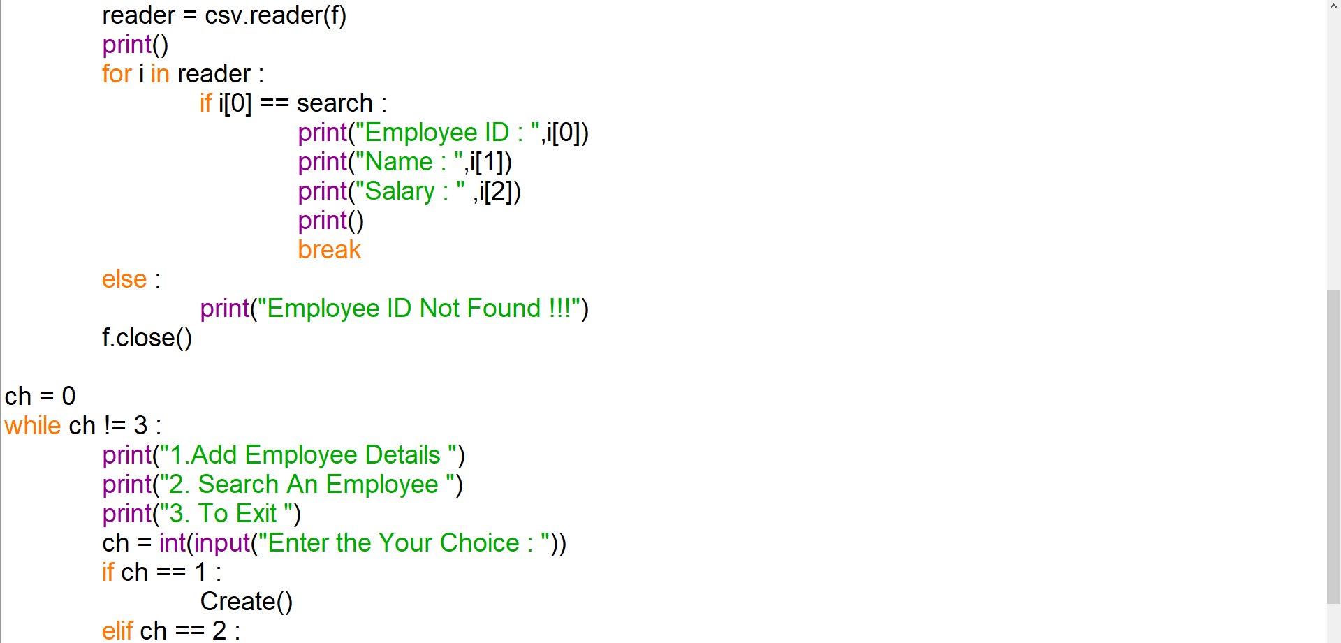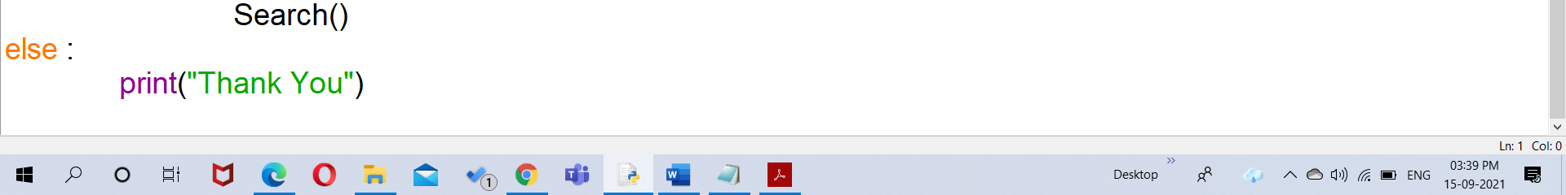

**Input/Output:**

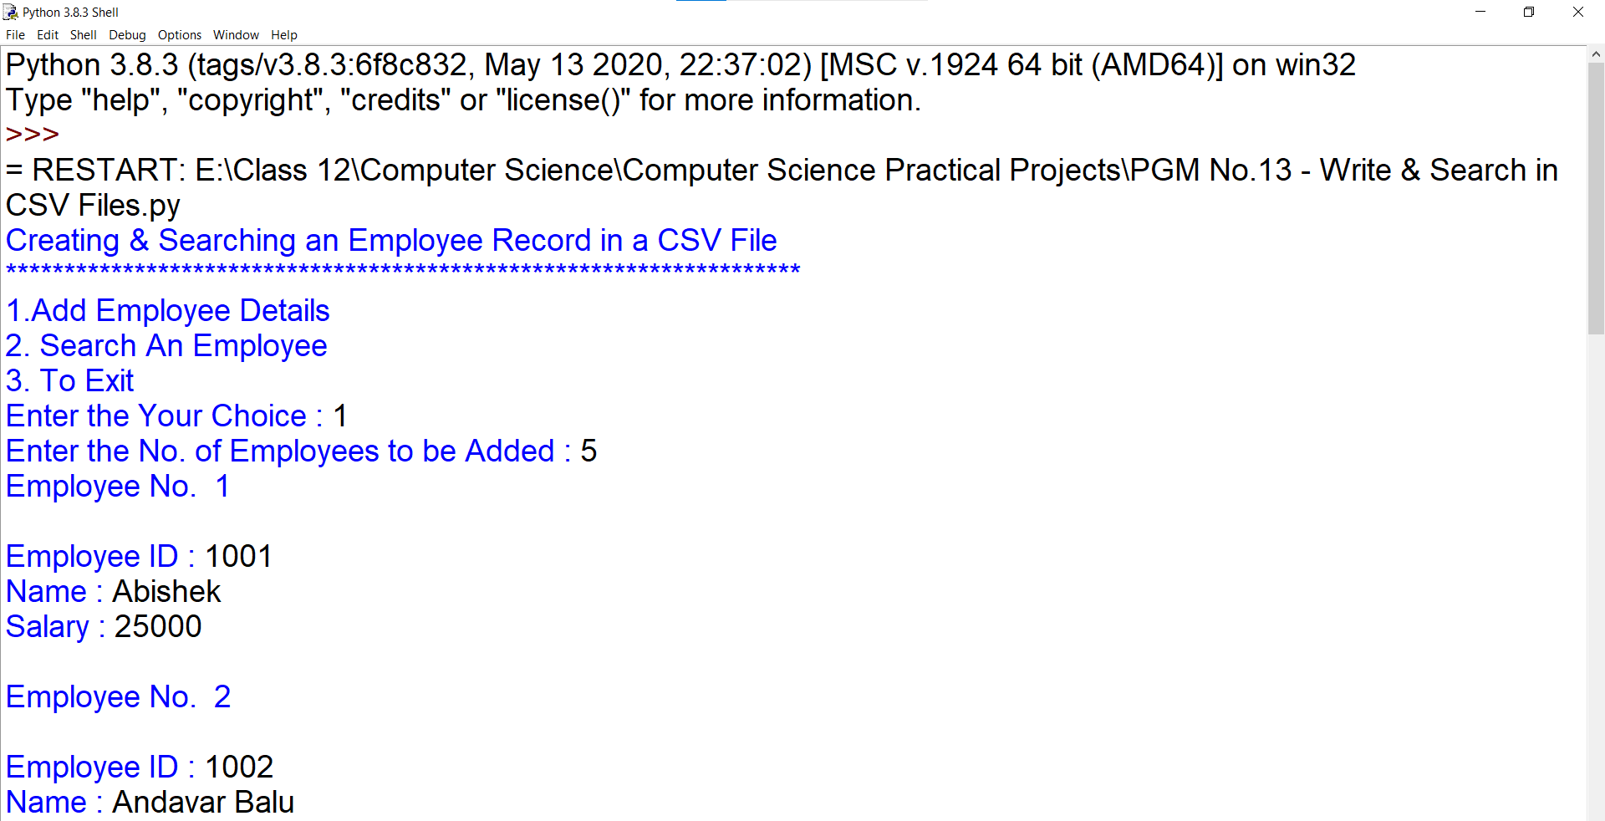

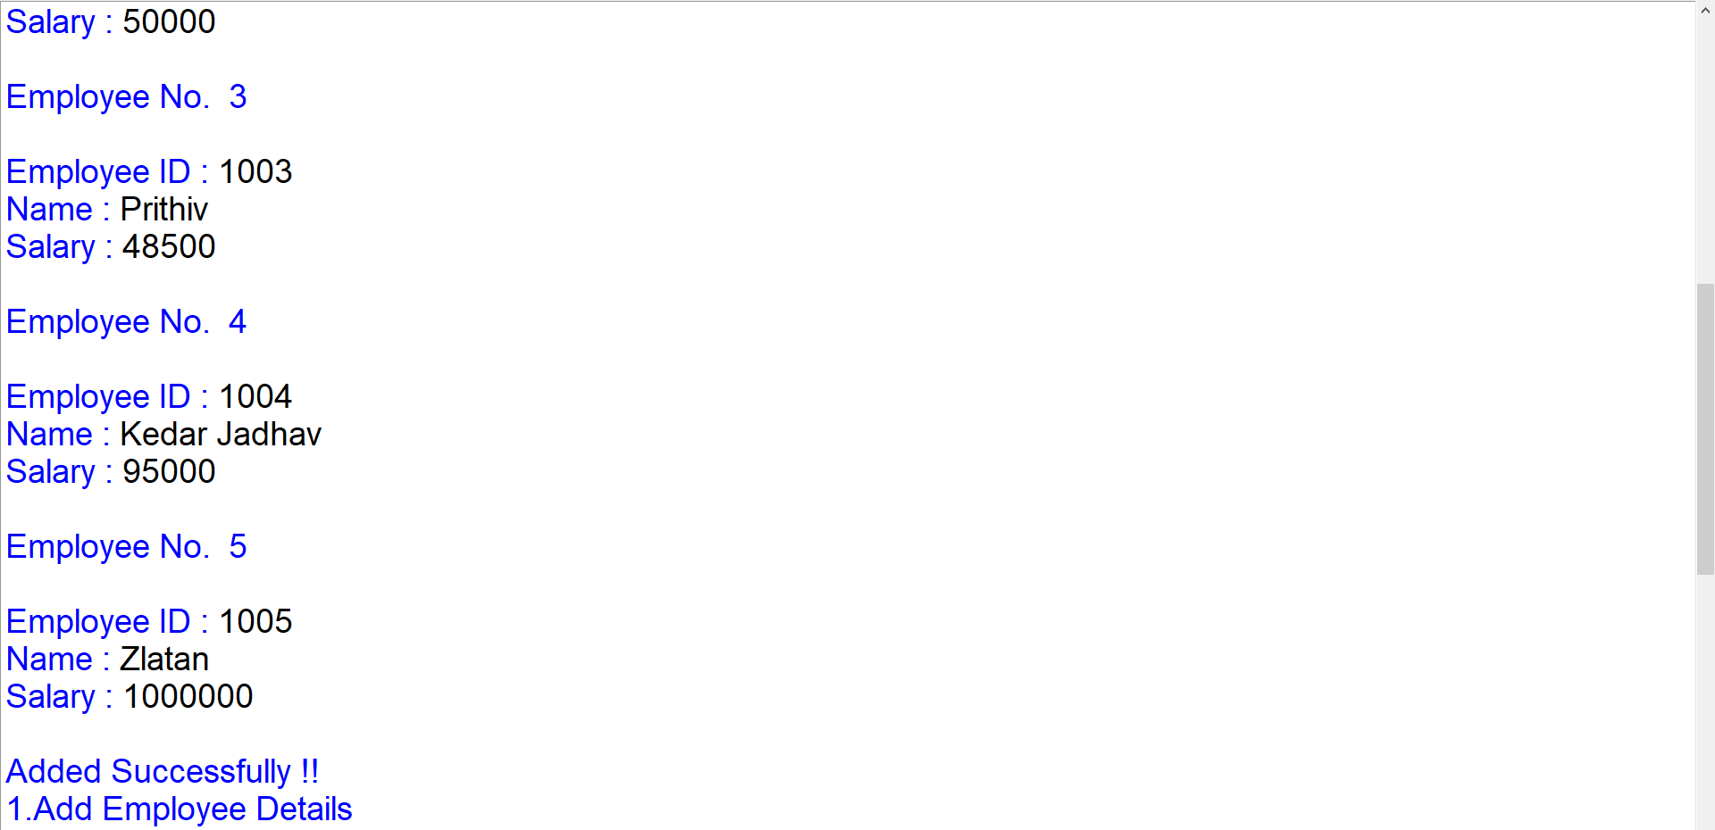

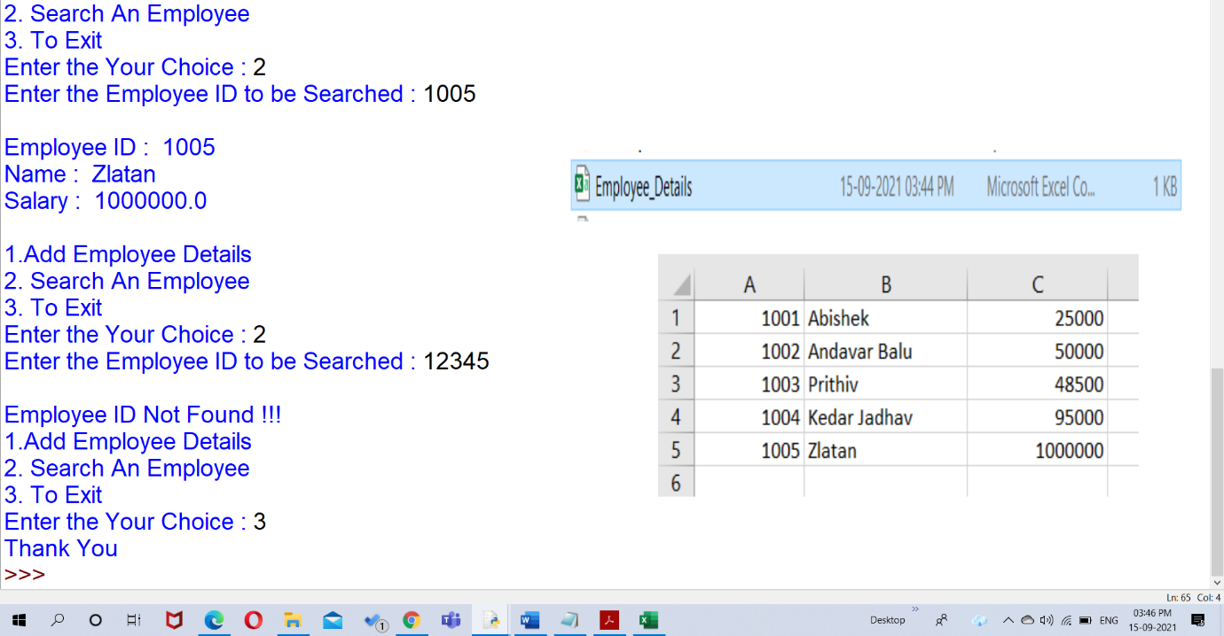

1. Write a program to generate random numbers between 1 to 6 and check whether a user won a lottery or not.

**Source Code:**

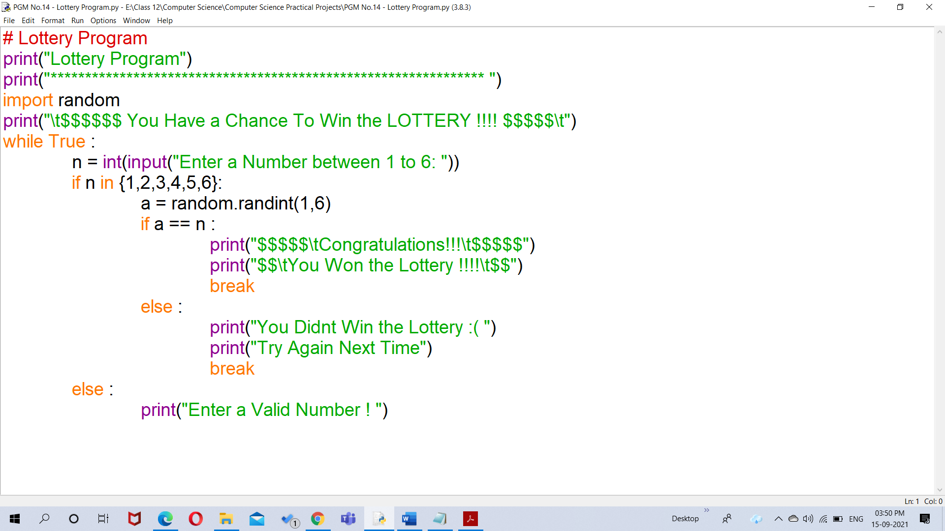

**Input/Output:**

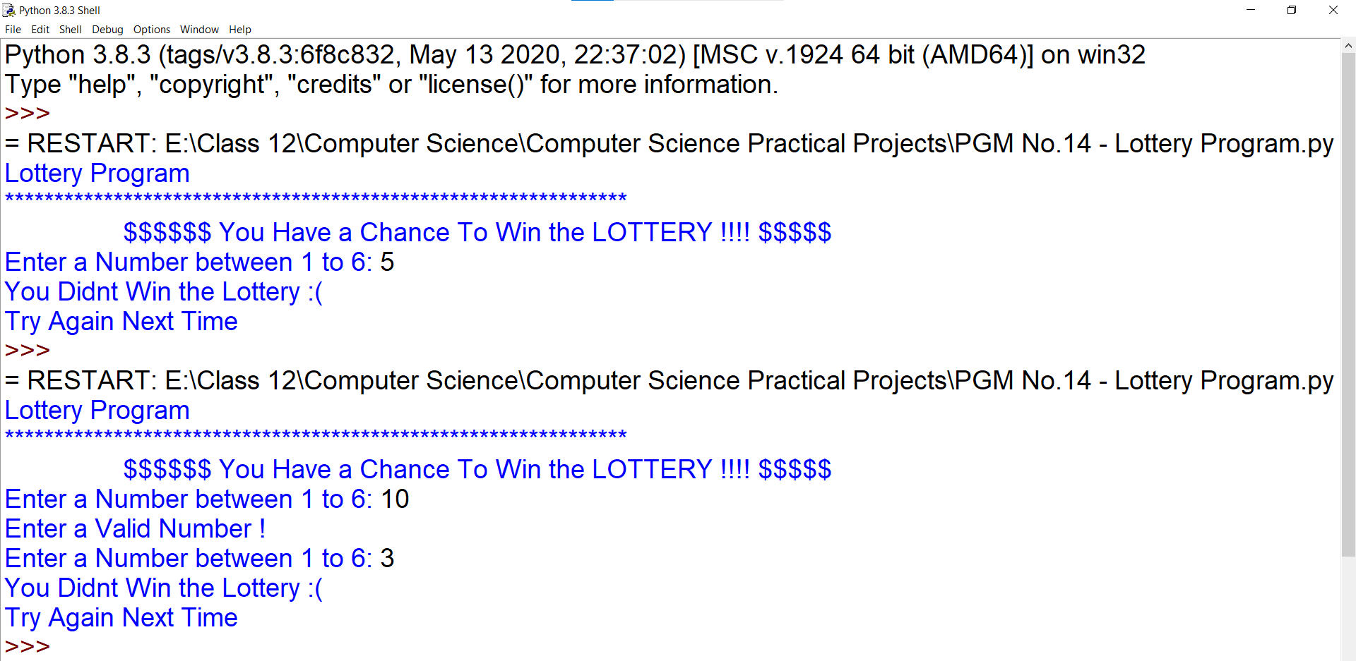

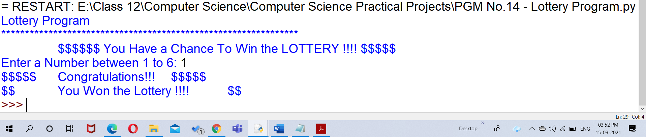

1. WAP creating a python program to make user define module and import same in another module or program to calculate area and perimeter of different shapes.

**Source Code:**

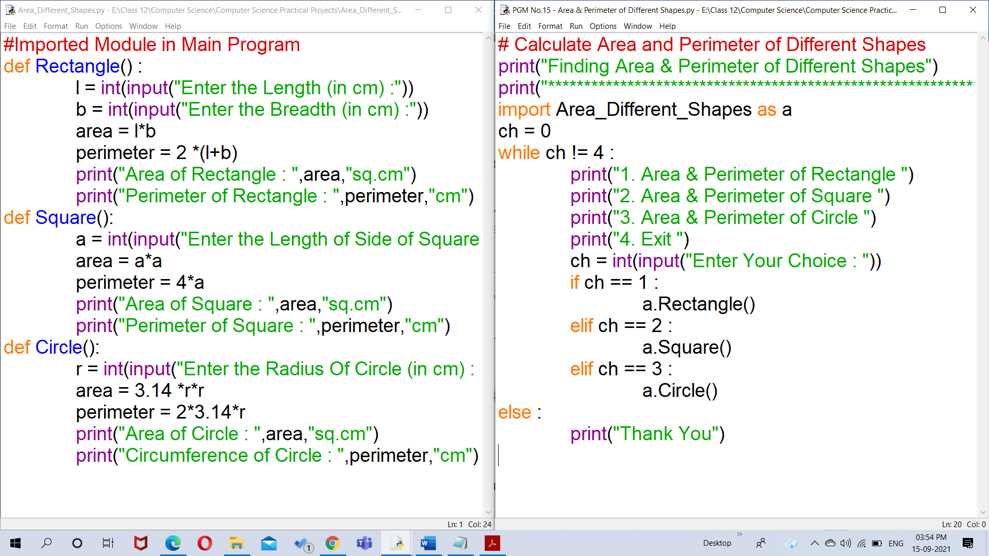

**Input/Output:**

